**Figure 1** Constructing a longitudinal cohort of 6.6 million US veterans to study risk factors of lower-extremity amputation

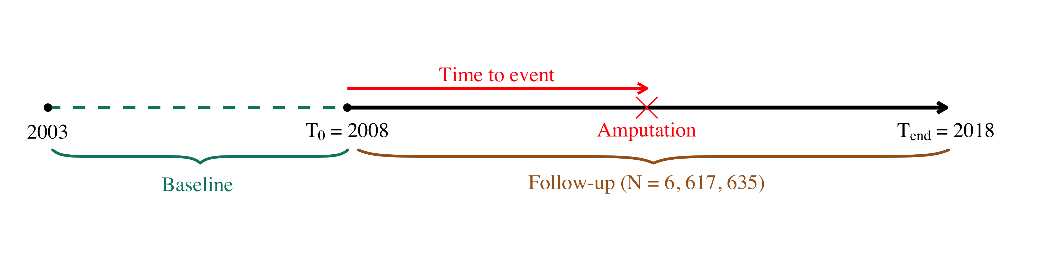

**Figure 2a** Crude and age-, gender-, and race-adjusted LEA rates among US veterans, 2008-2018

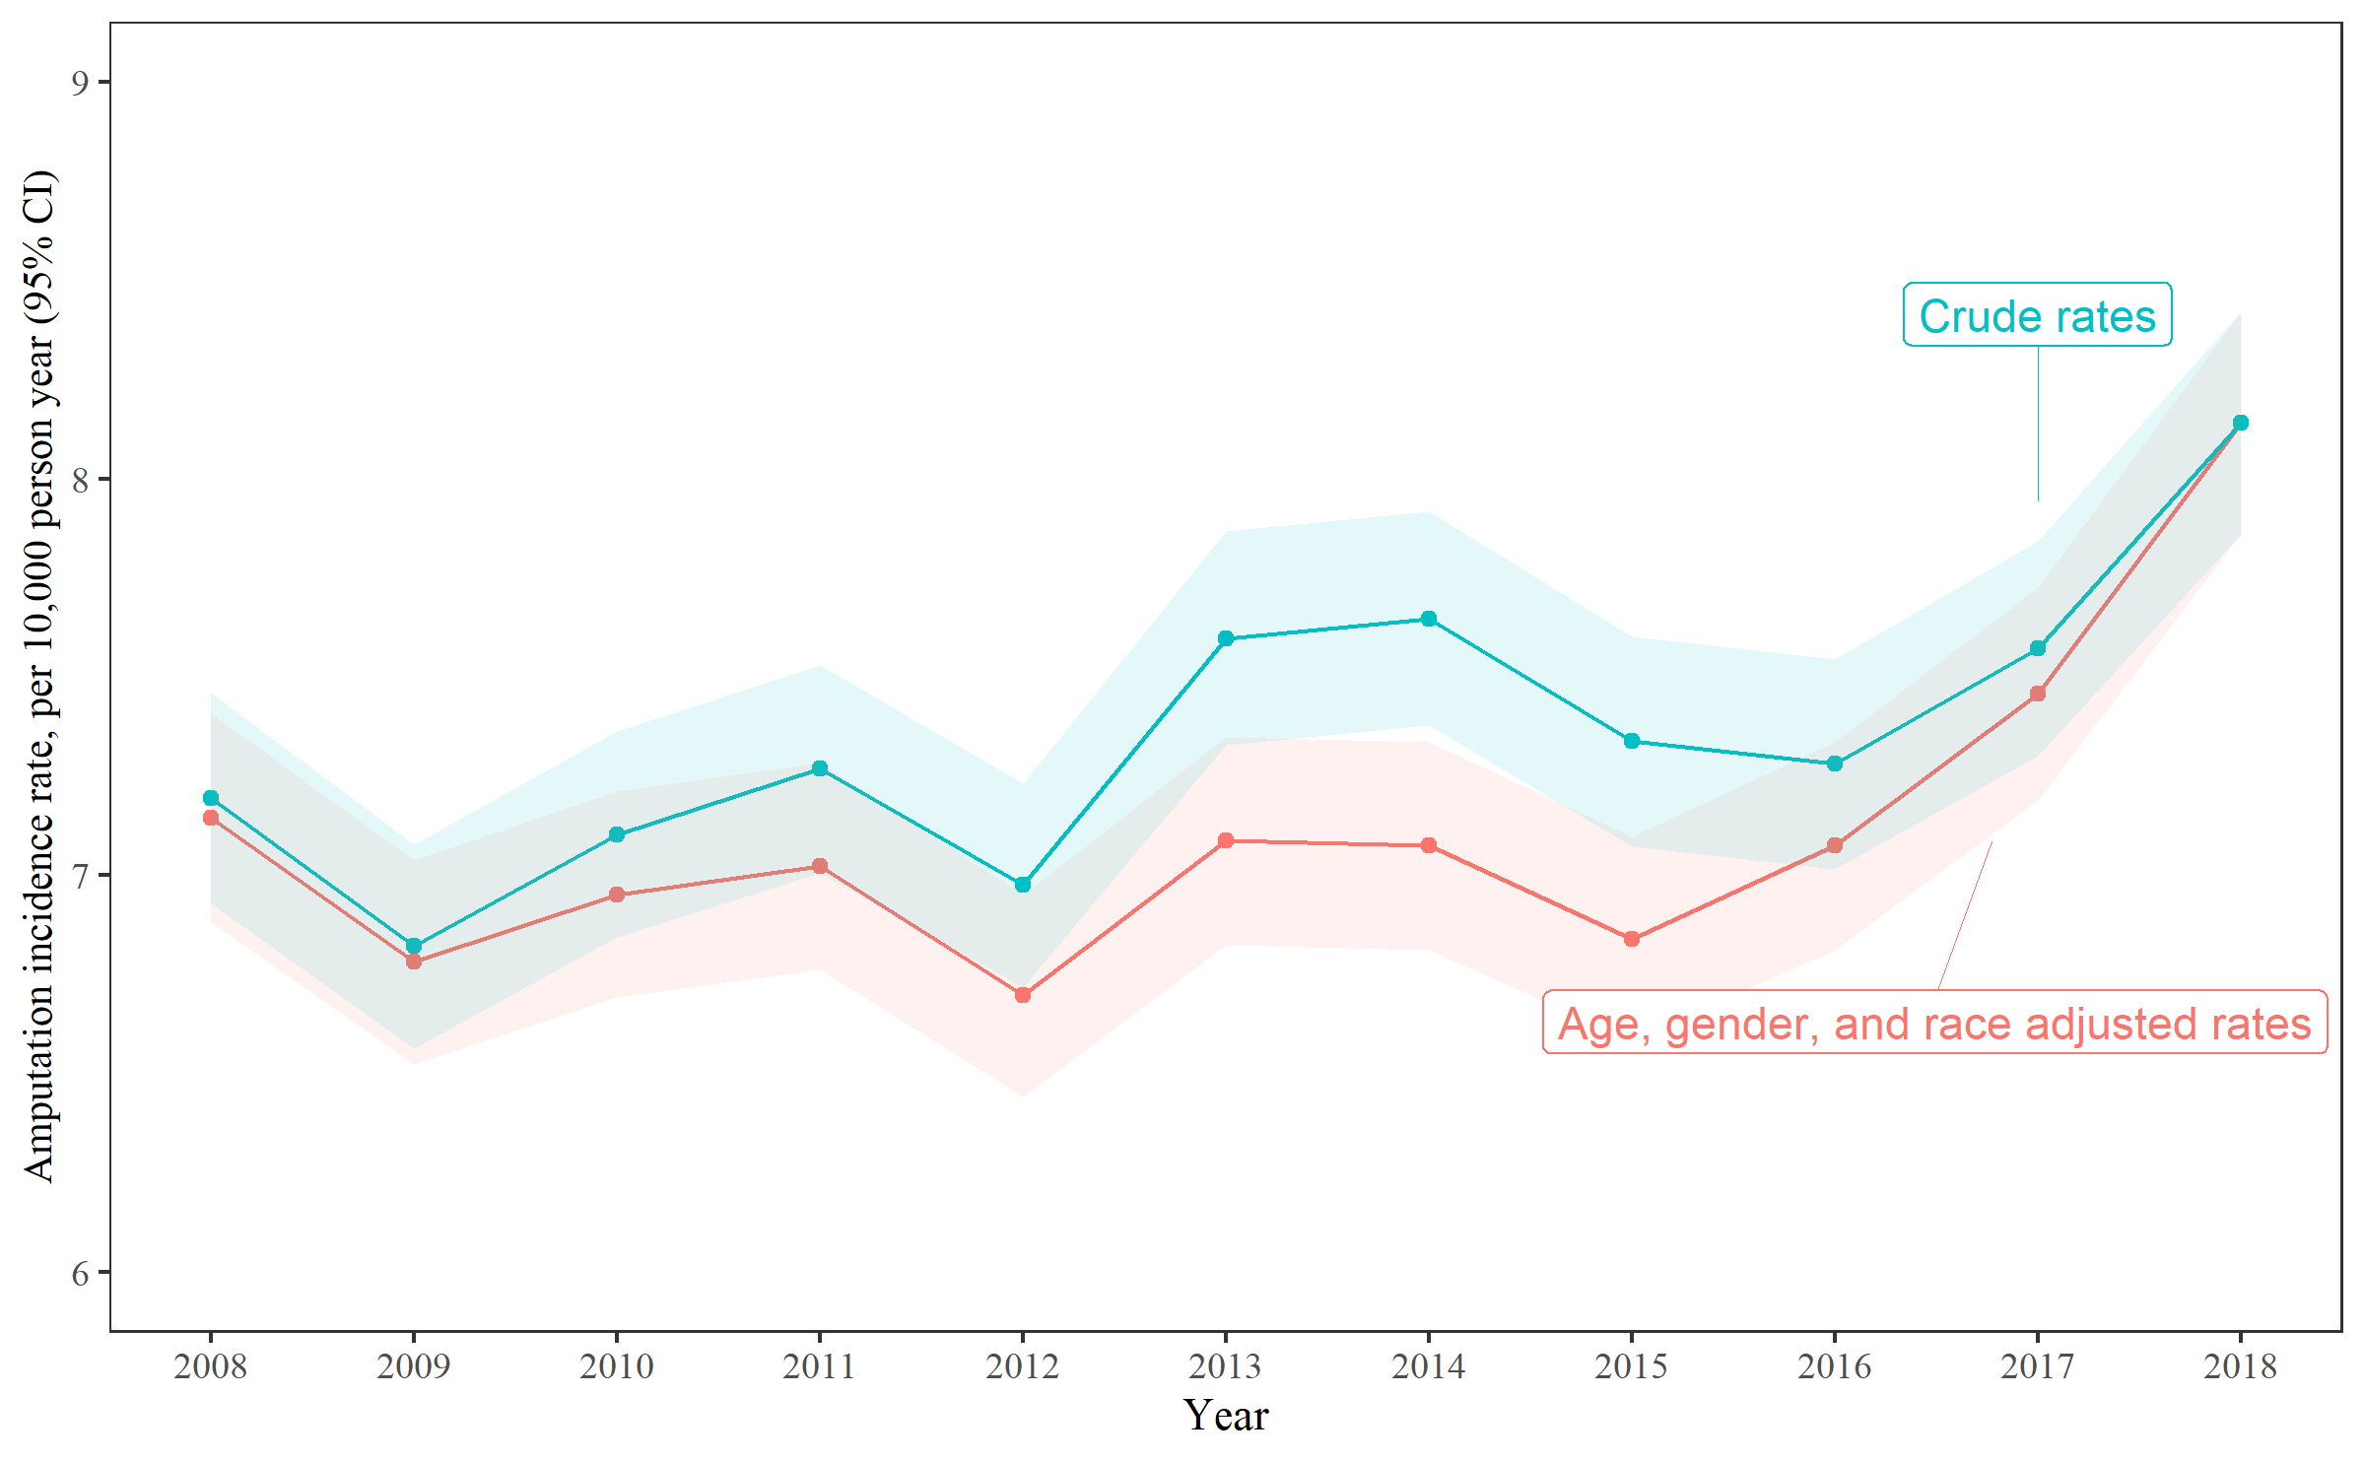

**Figure 2b** Age-, gender-, and race-adjusted LEA rates stratified by LEA among US veterans, 2008-2018

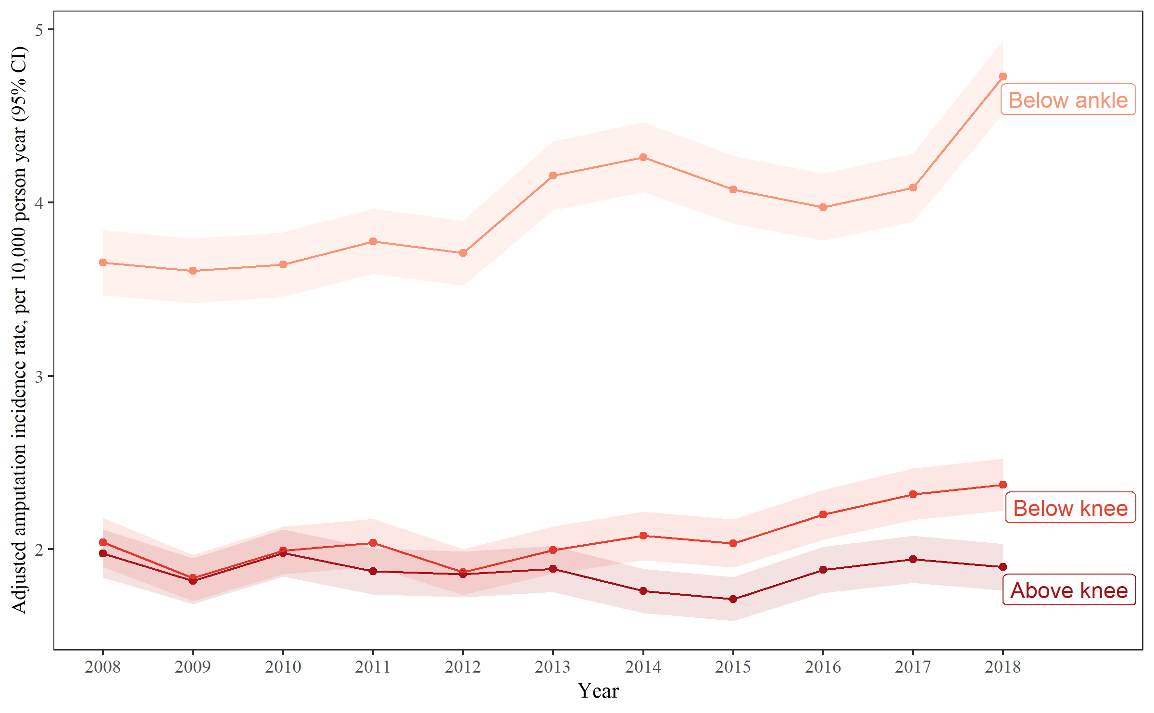

**Figure 3A**

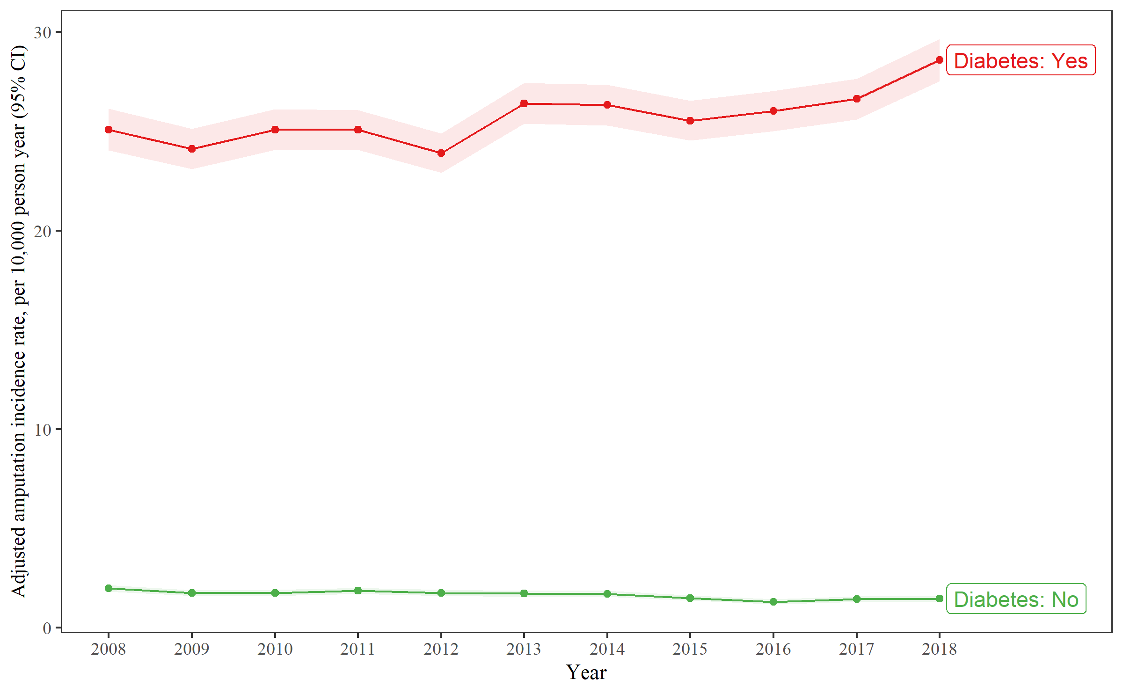

**Figure 3B**

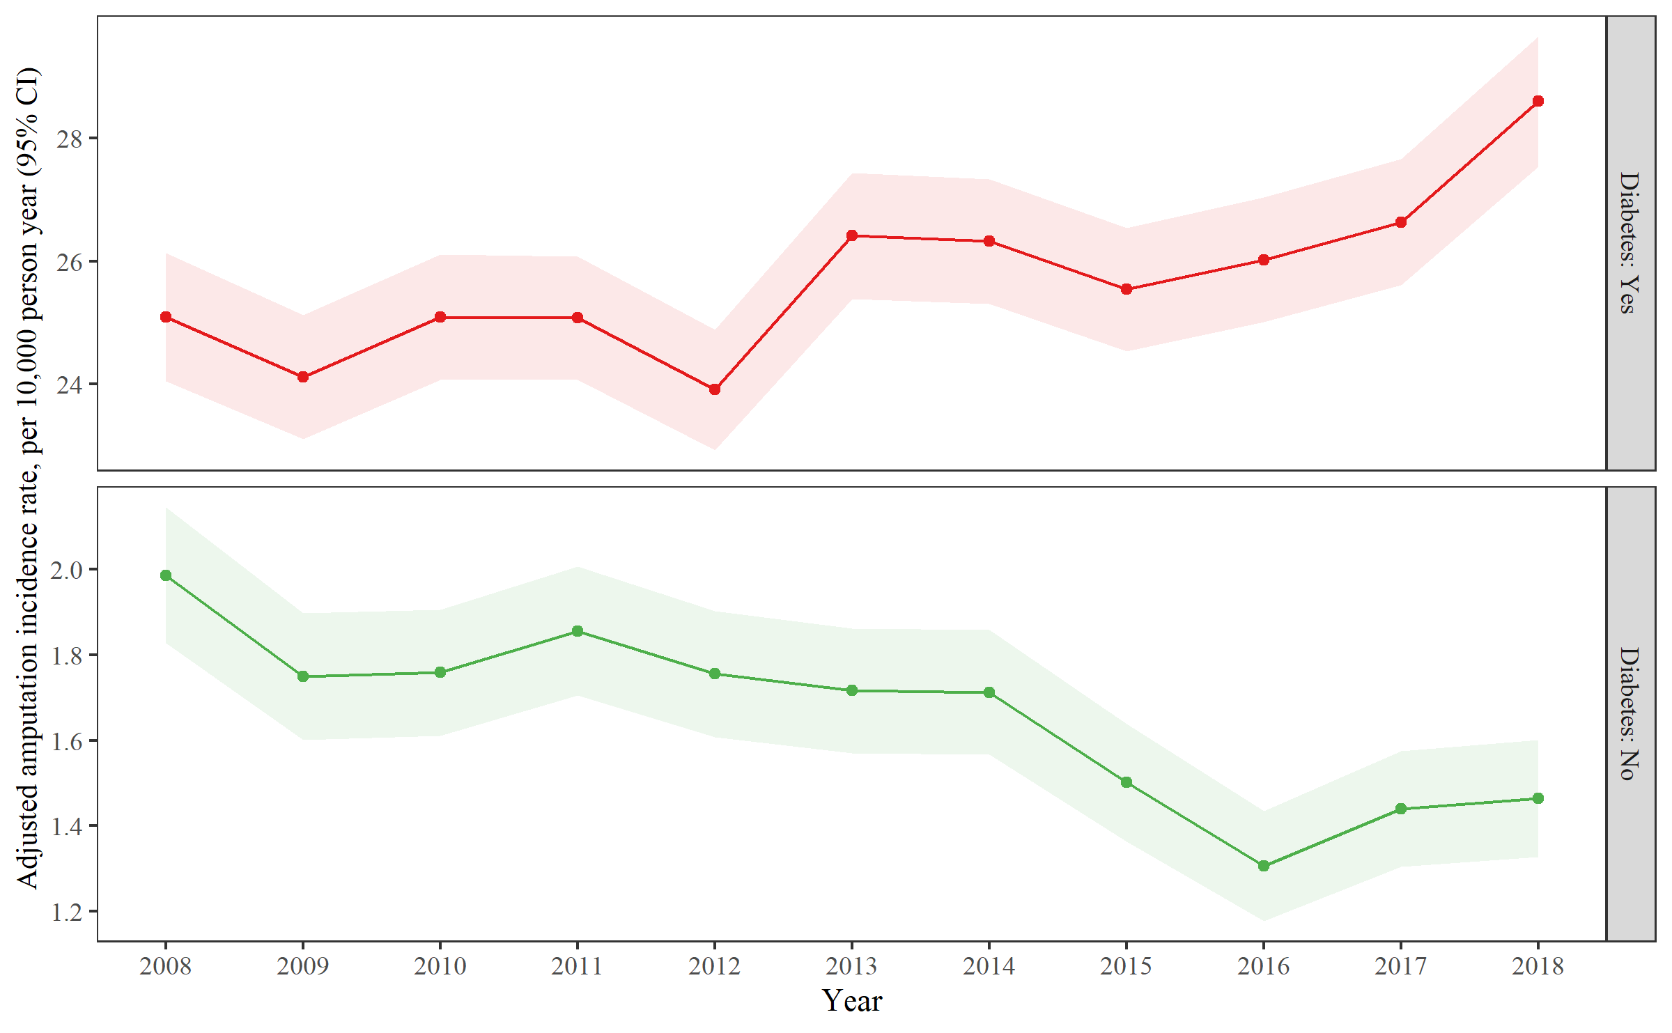

Figure 3CFigure 3D

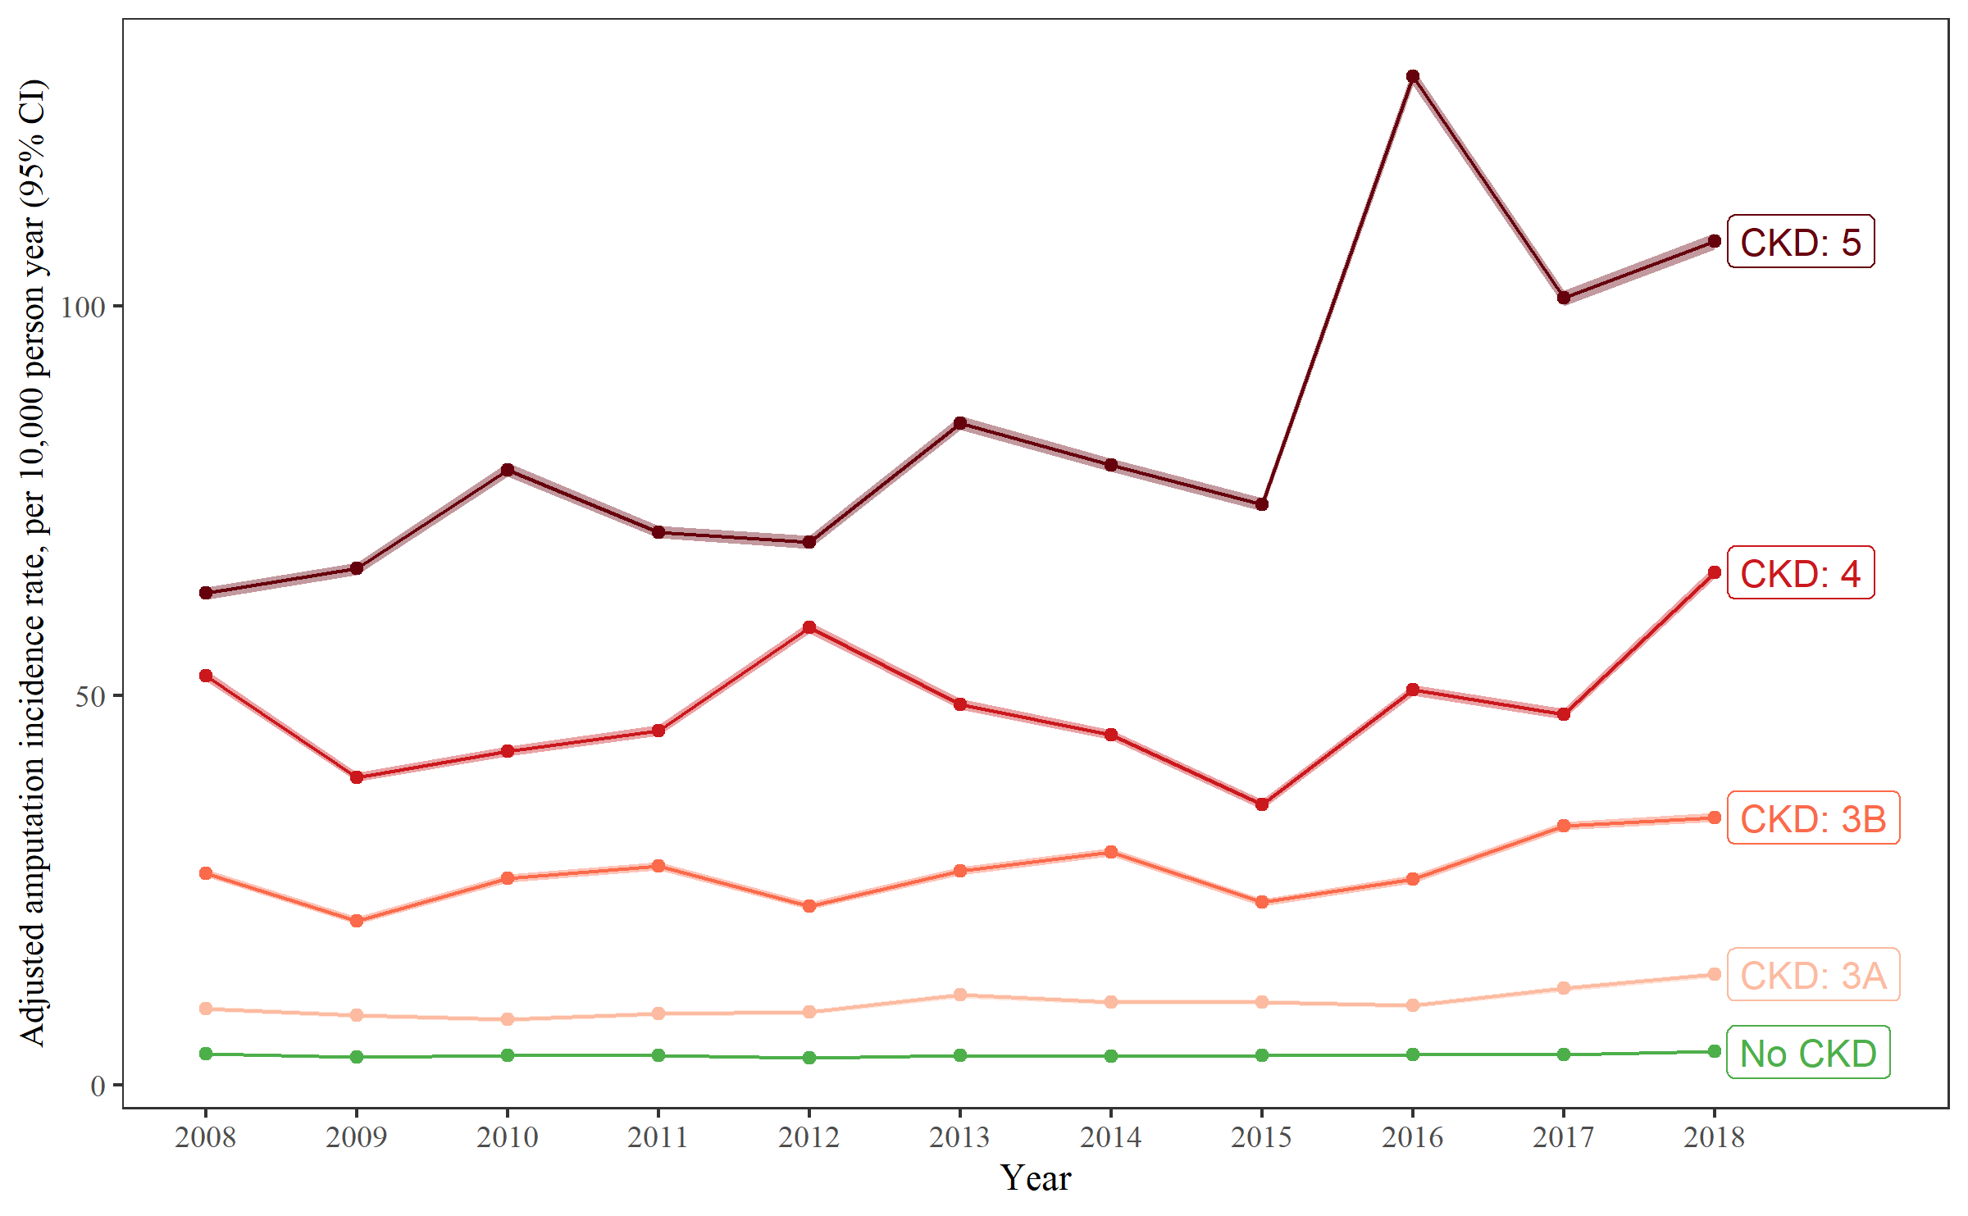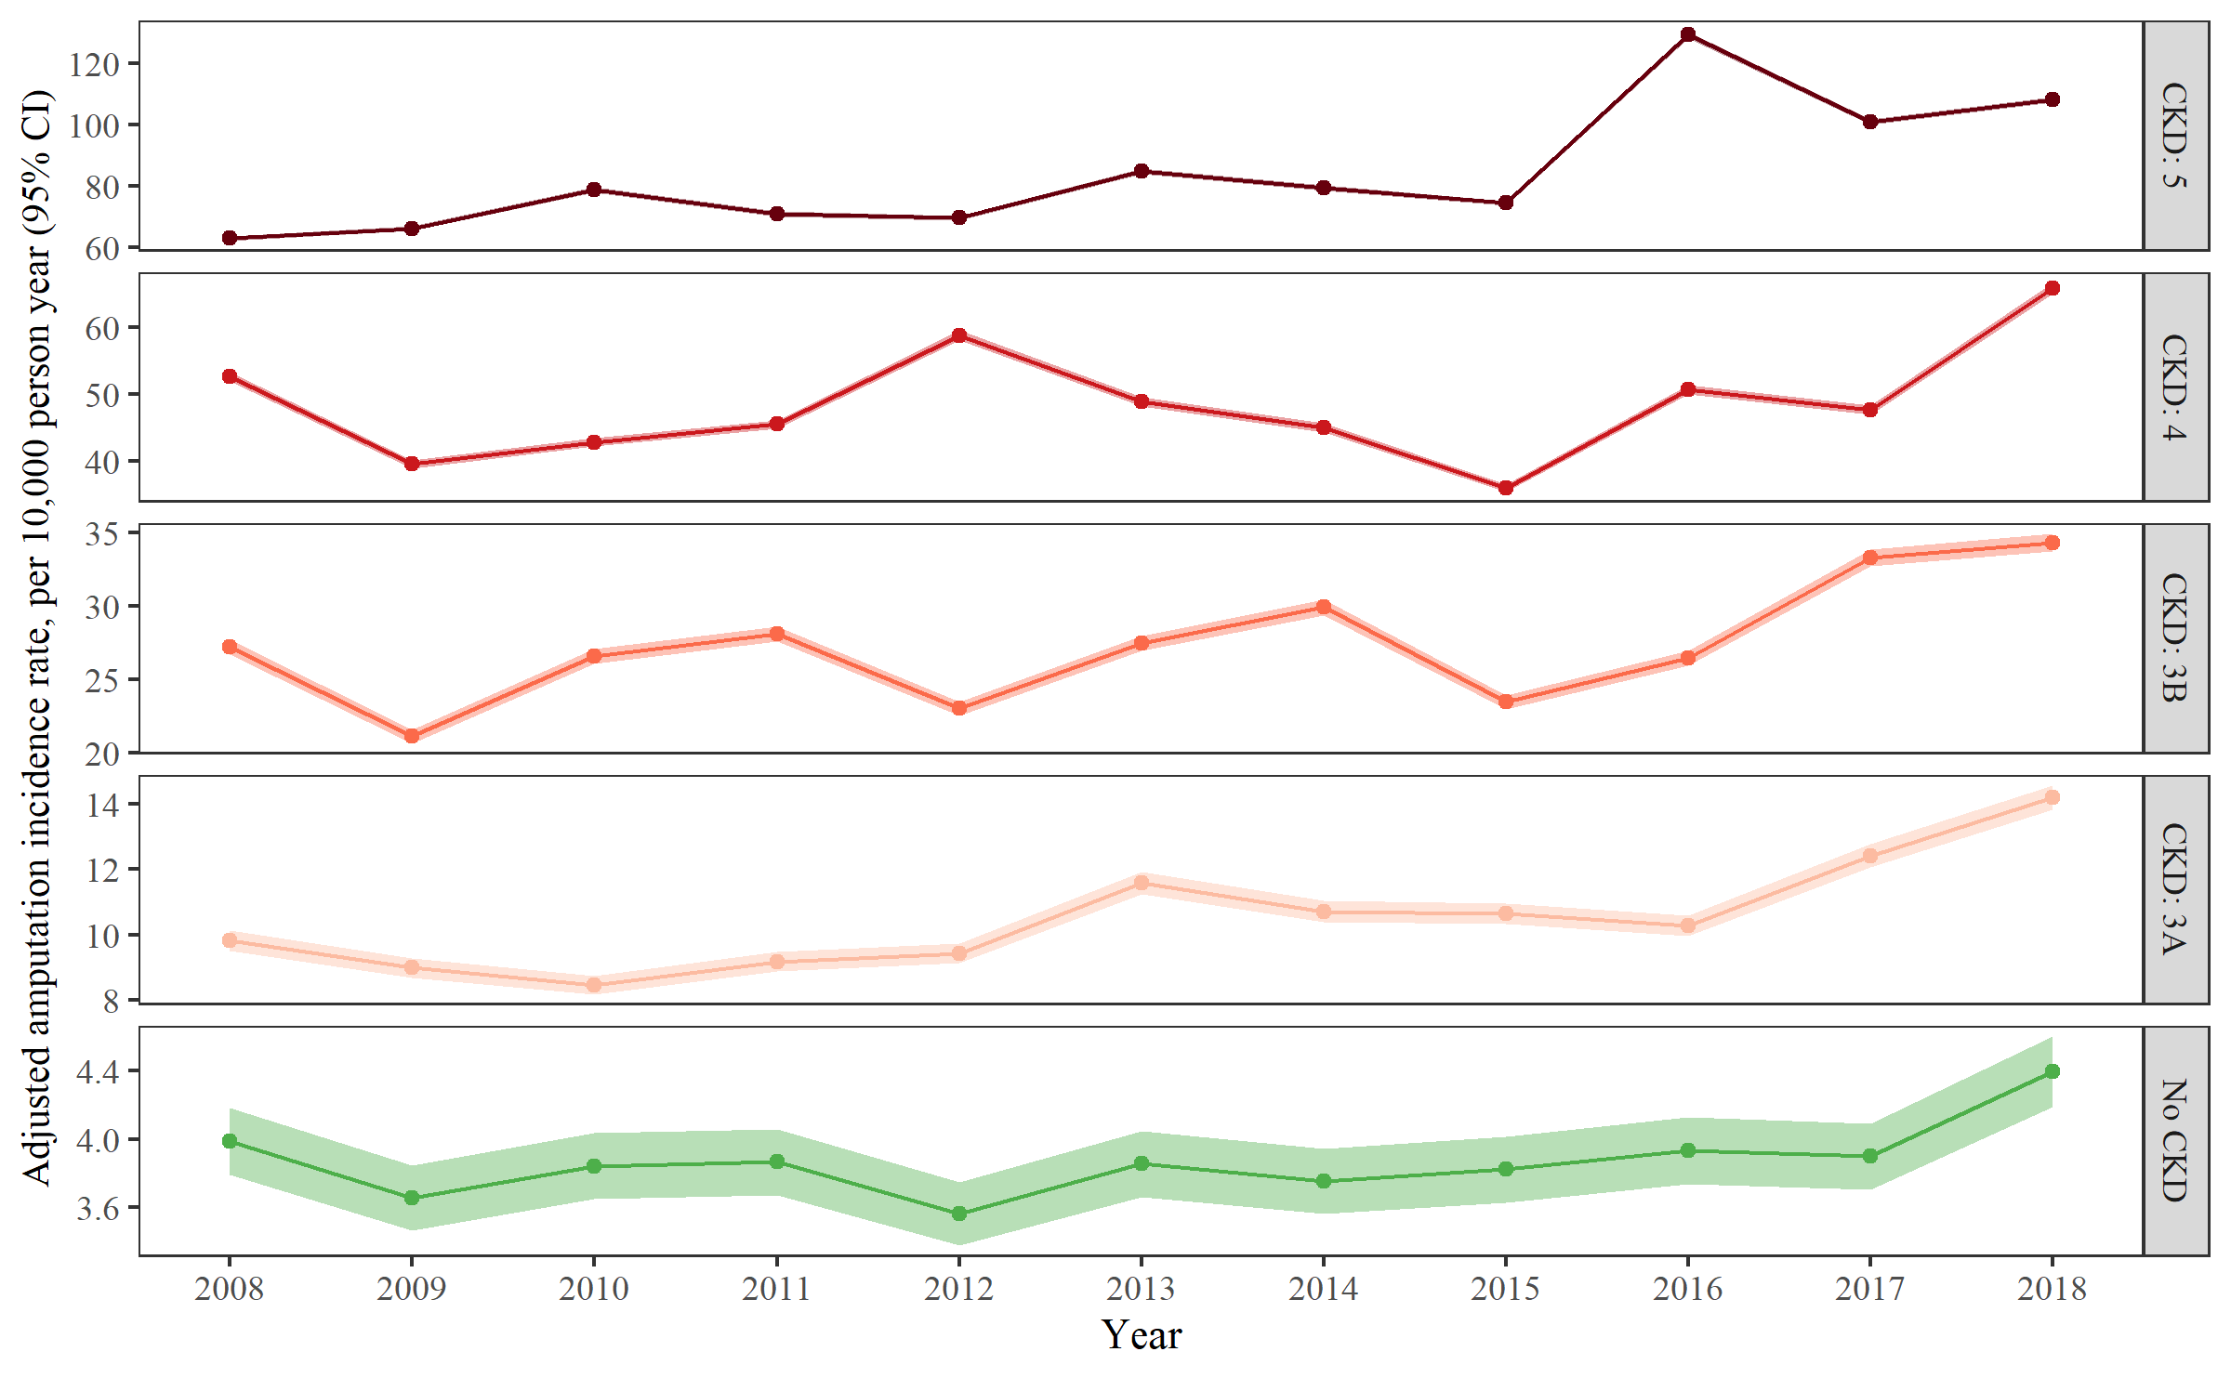

Figure 3E

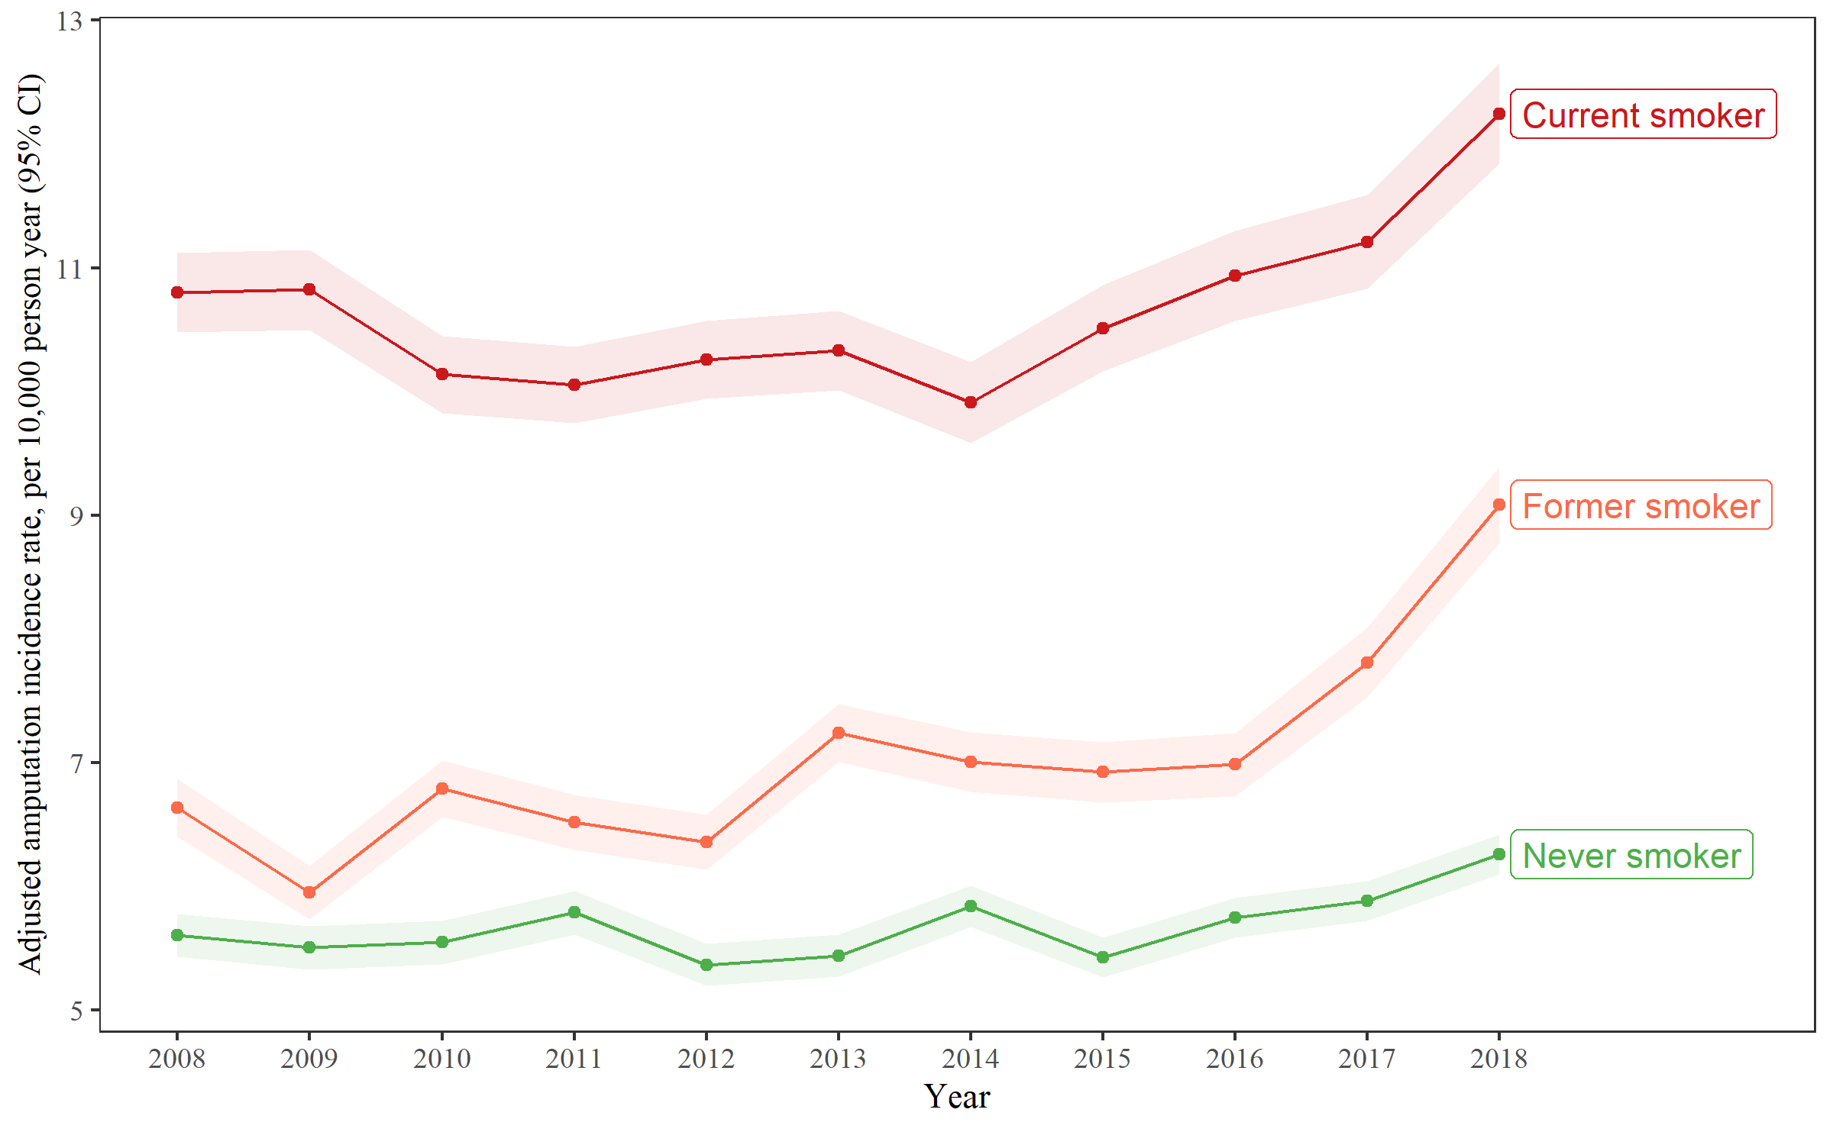

Figure 3F

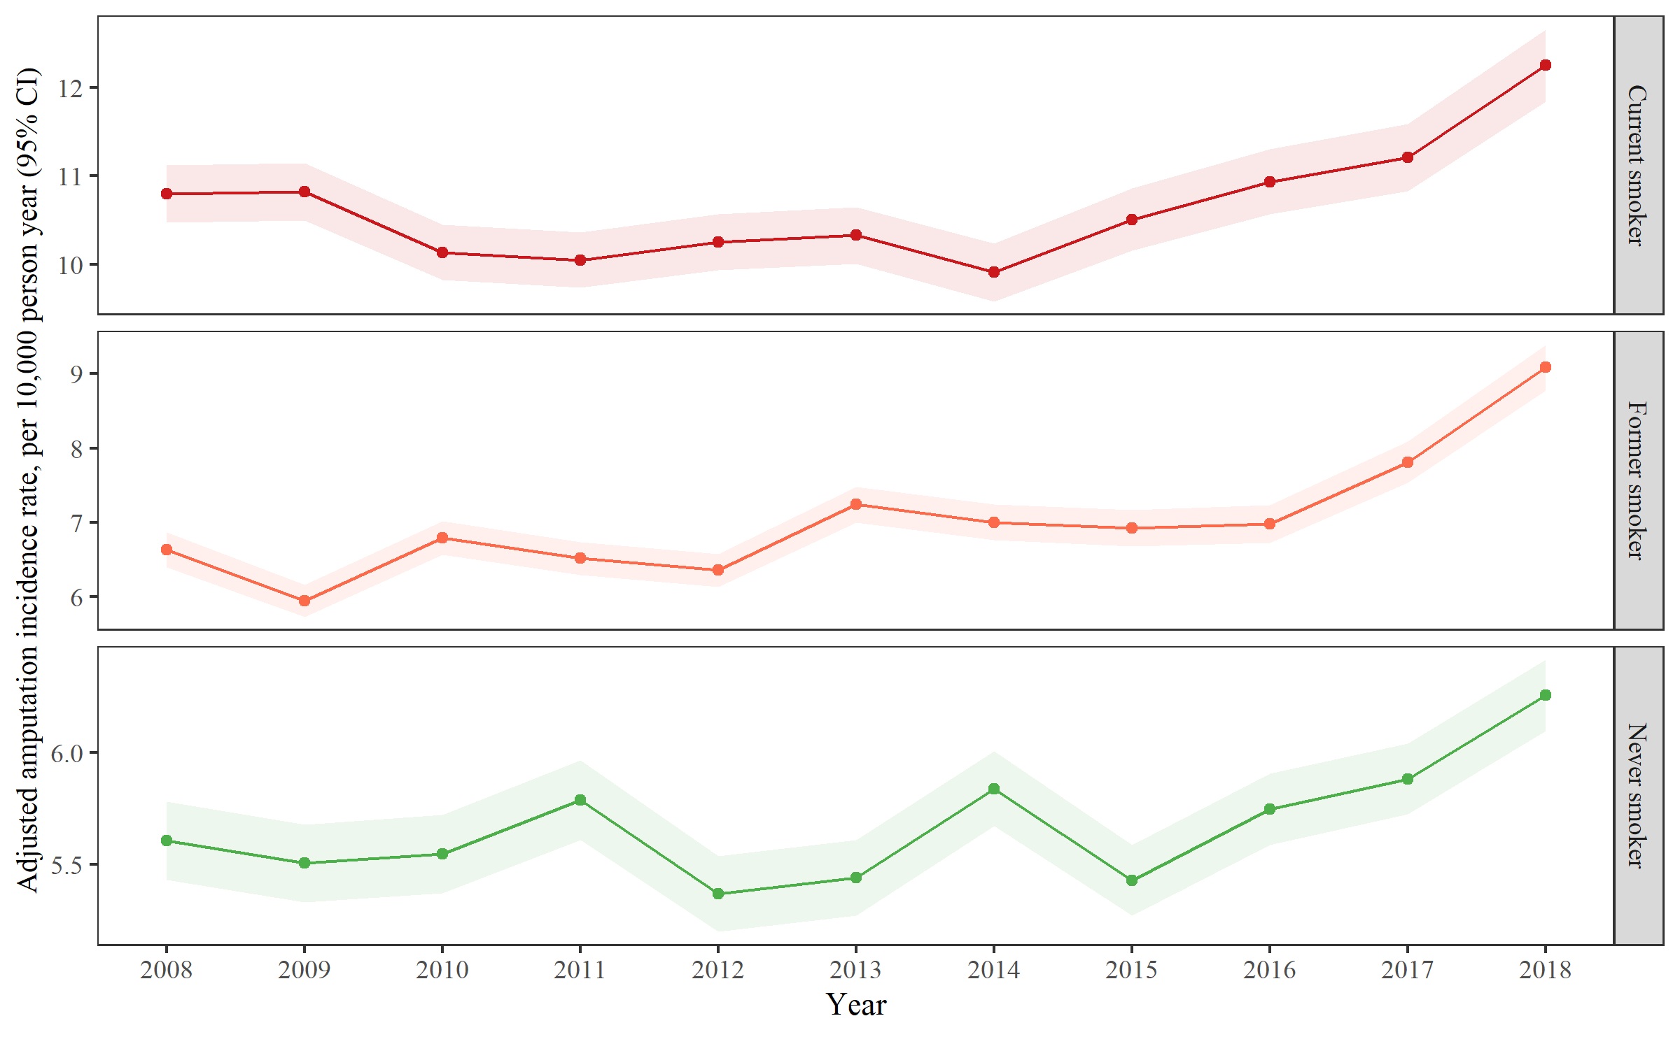

Figure 4 Maps of the age-, gender-, race-adjusted LEA rates among US veterans by FIPS codes

Figure 4A

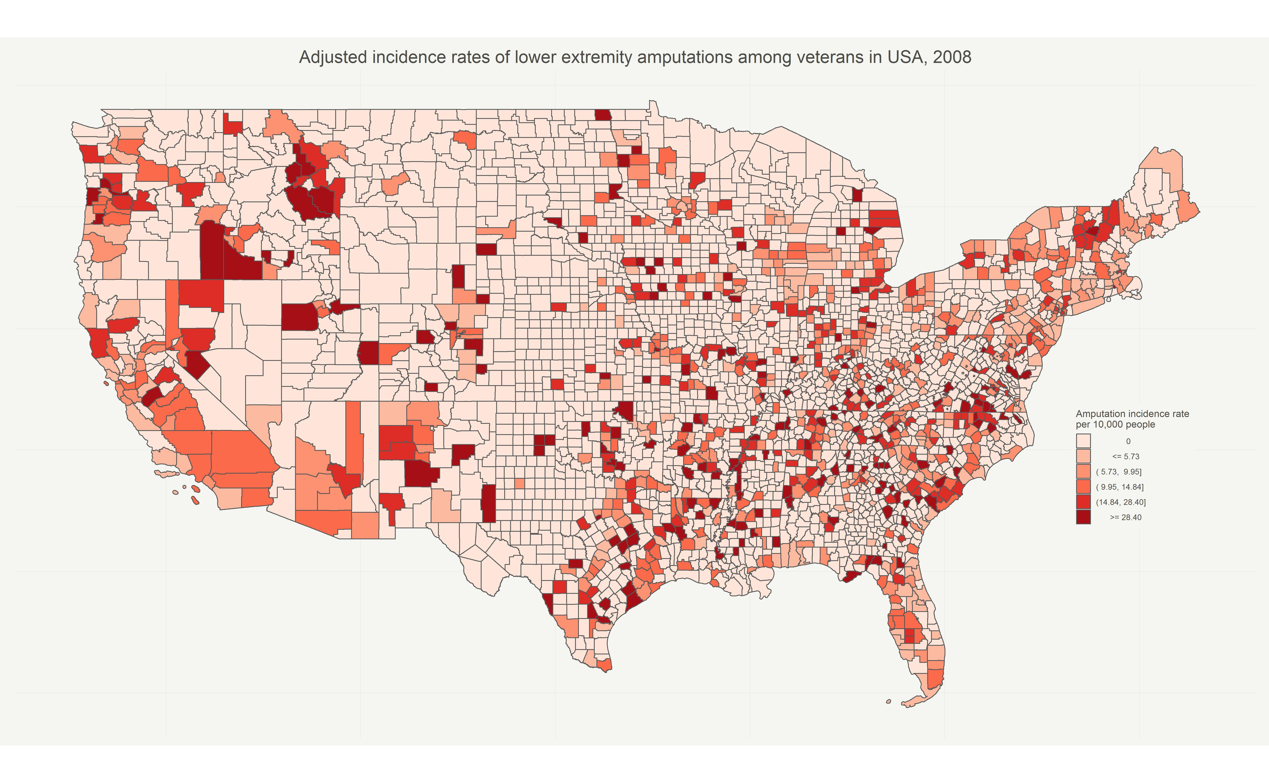

Figure 4B

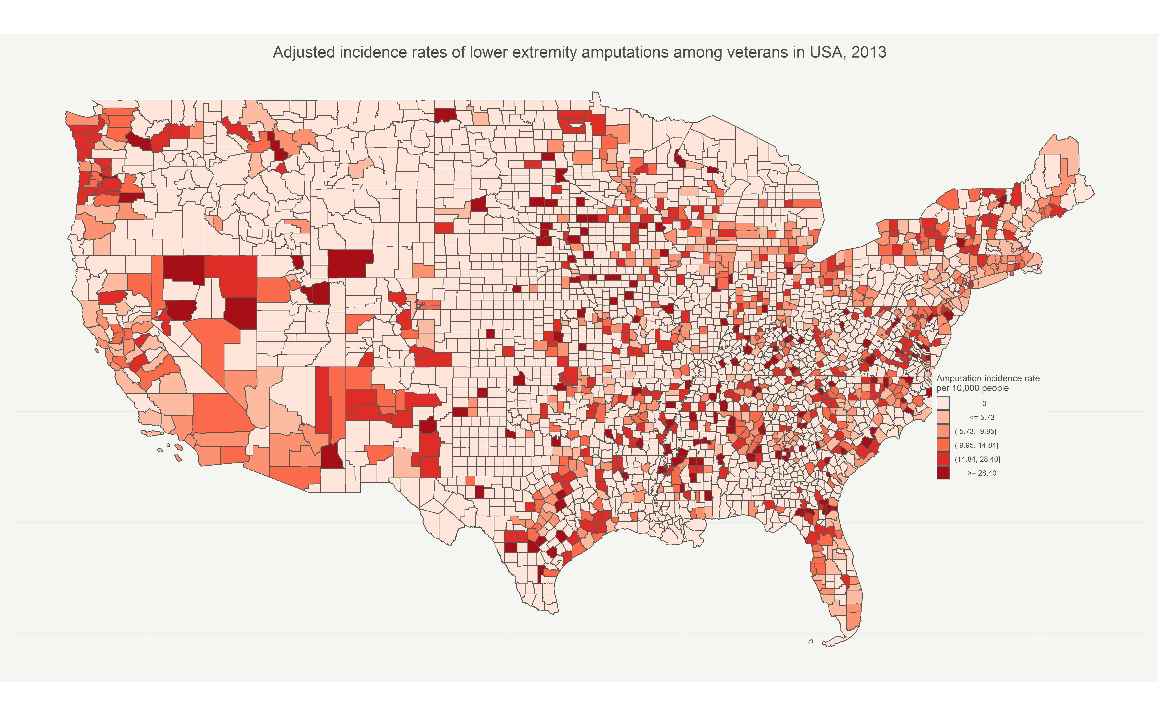

Figure 4C

